1-Mobile Network - Mobile Devices
# Source: AI Source: Provided by: [Data Path: Persons Table -> ID Column: 1, Name_En Column: Motasem Essam] -> From: [ChatGPT] on [1/23/2026]
Mobile Devices are end-user equipment that connect to mobile networks to send and receive data, make calls, and perform other wireless communication tasks.

📱 What Is End-User Equipment?
# Source: AI Source: Provided by: [Data Path: Persons Table -> ID Column: 1, Name_En Column: Motasem Essam] -> From: [ChatGPT] on [1/23/2026]
End-User Equipment (EUE) refers to devices used directly by people to access and interact with a communication or network system.

🔍 Simple Definition:
# Source: AI Source: Provided by: [Data Path: Persons Table -> ID Column: 1, Name_En Column: Motasem Essam] -> From: [ChatGPT] on [1/23/2026]
End-User Equipment is any device a person (the end user) uses to send, receive, or interact with data, such as making calls, browsing the internet, or sending messages.

💡 Examples of End-User Equipment in Mobile Networks:
# Source: AI Source: Provided by: [Data Path: Persons Table -> ID Column: 1, Name_En Column: Motasem Essam] -> From: [ChatGPT] on [1/23/2026]
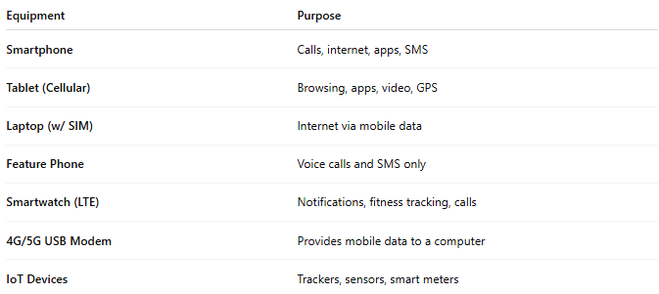

Equipment | Purpose
Smartphone | Calls, internet, apps, SMS
Tablet (Cellular) | Browsing, apps, video, GPS
Laptop (w/ SIM) | Internet via mobile data
Feature Phone | Voice calls and SMS only
Smartwatch (LTE) | Notifications, fitness tracking, calls
4G/5G USB Modem | Provides mobile data to a computer
IoT Devices | Trackers, sensors, smart meters

🧠 Why Is It Called “End-User” Equipment?
# Source: AI Source: Provided by: [Data Path: Persons Table -> ID Column: 1, Name_En Column: Motasem Essam] -> From: [ChatGPT] on [1/23/2026]
- "End": It's the final point in the network chain—used by people, not internal systems.
- "User": The person using the service (e.g., mobile data, calls).
- "Equipment": The device itself—hardware like a phone, modem, etc.

📡 In a Network Context:
# Source: AI Source: Provided by: [Data Path: Persons Table -> ID Column: 1, Name_En Column: Motasem Essam] -> From: [ChatGPT] on [1/23/2026]
A mobile phone connects to:
- Cell Tower →
- Carrier’s Core Network →
- Internet or other phone lines
The phone is end-user equipment—the last point where the data reaches the user.

✅ What Are Mobile Devices?
# Source: AI Source: Provided by: [Data Path: Persons Table -> ID Column: 1, Name_En Column: Motasem Essam] -> From: [ChatGPT] on [1/23/2026]
Mobile devices are portable computing and communication tools that access cellular networks using radio signals. They contain a SIM card and wireless communication hardware like GSM, LTE, or 5G modems.

🔍 Examples of Mobile Devices
# Source: AI Source: Provided by: [Data Path: Persons Table -> ID Column: 1, Name_En Column: Motasem Essam] -> From: [ChatGPT] on [1/23/2026]
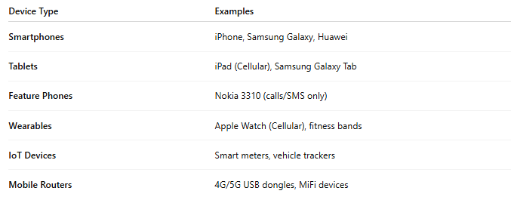

Device Type | Examples
Smartphones | iPhone, Samsung Galaxy, Huawei
Tablets | iPad (Cellular), Samsung Galaxy Tab
Feature Phones | Nokia 3310 (calls/SMS only)
Wearables | Apple Watch (Cellular), fitness bands
IoT Devices | Smart meters, vehicle trackers
Mobile Routers | 4G/5G USB dongles, MiFi devices

🧠 Key Internal Components
# Source: AI Source: Provided by: [Data Path: Persons Table -> ID Column: 1, Name_En Column: Motasem Essam] -> From: [ChatGPT] on [1/23/2026]
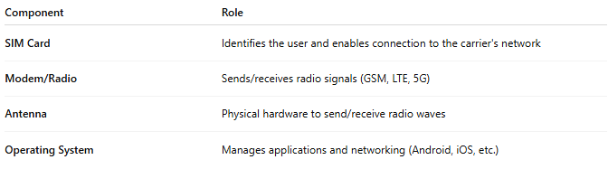

Component | Role
SIM Card | Identifies the user and enables connection to the carrier's network
Modem/Radio | Sends/receives radio signals (GSM, LTE, 5G)
Antenna | Physical hardware to send/receive radio waves
Operating System | Manages applications and networking (Android, iOS, etc.)

🛰️ What Do Mobile Devices Do on the Network?
# Source: AI Source: Provided by: [Data Path: Persons Table -> ID Column: 1, Name_En Column: Motasem Essam] -> From: [ChatGPT] on [1/23/2026]
- 📞 Initiate and receive voice calls
- 💬 Send and receive SMS and MMS
- 🌐 Access mobile data (3G/4G/5G)
- 📍 Use location services (GPS + network triangulation)
- 🔐 Authenticate with the network using SIM credentials

🔁 Interaction with the Network
# Source: AI Source: Provided by: [Data Path: Persons Table -> ID Column: 1, Name_En Column: Motasem Essam] -> From: [ChatGPT] on [1/23/2026]
- Device powers on
- Modem connects to nearest cell tower
- SIM authenticates with mobile carrier
- IP address is assigned for data
- User can now make calls, send texts, and use internet

2-Roaming

🌍 What Is Roaming in Mobile Networks?
# Source: AI Source: Provided by: [Data Path: Persons Table -> ID Column: 1, Name_En Column: Motasem Essam] -> From: [ChatGPT] on [1/23/2026]
Roaming is the ability of your mobile device to automatically connect to a different network when you're outside your home network’s coverage area — usually in another country or region.
📲 Roaming lets you make calls, send texts, and use mobile data while traveling, without changing your SIM card or phone number.

🧭 Types of Roaming:
# Source: AI Source: Provided by: [Data Path: Persons Table -> ID Column: 1, Name_En Column: Motasem Essam] -> From: [ChatGPT] on [1/23/2026]
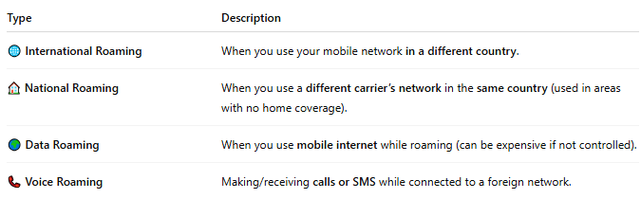

Type | Description
🌐 International Roaming | When you use your mobile network in a different country.
🏠 National Roaming | When you use a different carrier’s network in the same country (used in areas with no home coverage).
🌍 Data Roaming | When you use mobile internet while roaming (can be expensive if not controlled).
📞 Voice Roaming | Making/receiving calls or SMS while connected to a foreign network.

🔁 How Roaming Works:
# Source: AI Source: Provided by: [Data Path: Persons Table -> ID Column: 1, Name_En Column: Motasem Essam] -> From: [ChatGPT] on [1/23/2026]
- 📱 You travel to another country.
- 📡 Your phone connects to a partner network via a roaming agreement.
- 🧠 Your home network is contacted through a global system (like SS7 or IPX).
- 📞 You can now make calls, text, and access the internet — as if you were on your home network.

🔐 Key Behind-the-Scenes Elements:
# Source: AI Source: Provided by: [Data Path: Persons Table -> ID Column: 1, Name_En Column: Motasem Essam] -> From: [ChatGPT] on [1/23/2026]
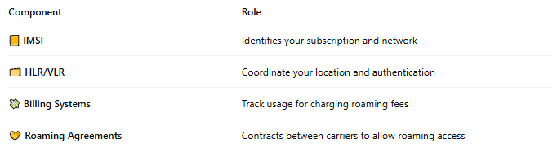

Component | Role
📒 IMSI | Identifies your subscription and network
🗂️ HLR/VLR | Coordinate your location and authentication
💸 Billing Systems | Track usage for charging roaming fees
🤝 Roaming Agreements | Contracts between carriers to allow roaming access

💸 Is Roaming Free?
# Source: AI Source: Provided by: [Data Path: Persons Table -> ID Column: 1, Name_En Column: Motasem Essam] -> From: [ChatGPT] on [1/23/2026]
Not always. It depends on:
- ✅ Your mobile plan
- 🌍 The country you're in
- 🤝 Whether your carrier has an agreement with the local provider
📌 Some carriers offer roaming packages or free EU roaming zones, while others charge per MB, minute, or message.

⚠️ Roaming Risks & Tips:
# Source: AI Source: Provided by: [Data Path: Persons Table -> ID Column: 1, Name_En Column: Motasem Essam] -> From: [ChatGPT] on [1/23/2026]
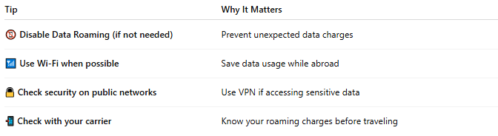

Tip | Why It Matters
📵 Disable Data Roaming (if not needed) | Prevent unexpected data charges
📶 Use Wi-Fi when possible | Save data usage while abroad
🔒 Check security on public networks | Use VPN if accessing sensitive data
📲 Check with your carrier | Know your roaming charges before traveling

📖 Summary:
# Source: AI Source: Provided by: [Data Path: Persons Table -> ID Column: 1, Name_En Column: Motasem Essam] -> From: [ChatGPT] on [1/23/2026]
Roaming lets your phone stay connected while traveling outside your network’s home area — using partner networks for calls, texts, and data. It’s convenient, but often comes with extra charges unless you’re on a roaming plan.

